Institution | Kazan National Research Technological University | Reporting period | 01.10.2019 – 31.01.2020

Key for “Type” of activity: A. Distribution of information
B. Project presentations
C. Articles and postings (websites, blogs, newspapers, journals, books etc.).
Note: you do not need to fill in columns marked with * for type C.
D. Other activities

No | Country | Type | Description of the activity  (‘Medium’ used, if entry is for an activity of type C) | Target groups | No. of  institutions* | No. of  Persons* | Date | Documentation | Comments  (effects, observations, problems etc.)
 | RU | B | Presentation of the MODEST project and its current status to P10 PhD students. | KNRTU PhD students and faculty interested in modernization of doctoral education and participation in international cooperation projects supported by EU. | 1 | ~50 | 08.10.2019 | Please see Annex 1.
 | RU | С | Publication of research paper “Development of Soft Skills as a Part of Foreign Language Training of PhD Students”  (In Russian, "Vestnik of Lobachevsky State University of Nizhni Novgorod. Series: Social Sciences")”, #4(56), 2019, pp. 273-277. | Russian HEIs and scientist community interested in training f PhD students |  |  | January 2020 | Please see Annex 2.
 | RU | C | The results of MODEST consortium meetings held in Riga on December 17-18, 2019 were posted online on the university website(in Russian) | KNRTU administration, faculty and students, university website visitors |  |  | 30.12.2019 | https://www.kstu.ru/event.jsp?id_a=24247&id=106474
 | RU | C | The results of MODEST consortium meetings held in Riga on December 17-18, 2019 were posted online on the university website (in English) | KNRTU administration, faculty and students, university website visitors |  |  | 30.12.2019 | https://www.kstu.ru/event.jsp?id=106473
 | RU | A | Information about MODEST Consortium was included in the annual report of P10 dedicated to its activities as a national research university of Russia. This report includes the most important events of university’s education, research and internationalization. | Russian Ministry of Higher Education and Science | 1 | N/A | 31.01.2020 | Please see Annex 3.

Annex 1.
Publication of research paper “Development of Soft Skills as a Part of Foreign Language Training of PhD Students”.

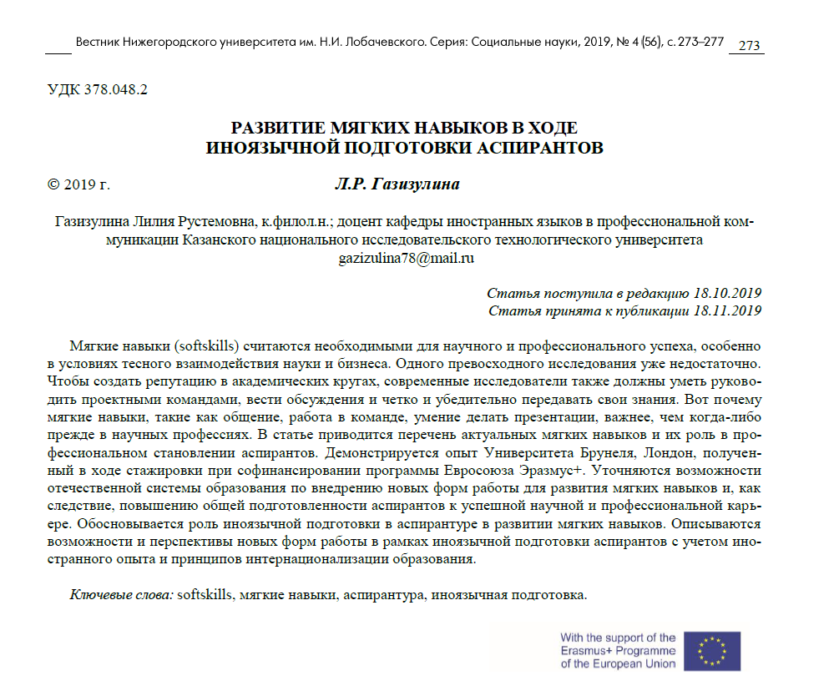
Annex 2.
Presentation of the MODEST project and its current status to P10 PhD students.
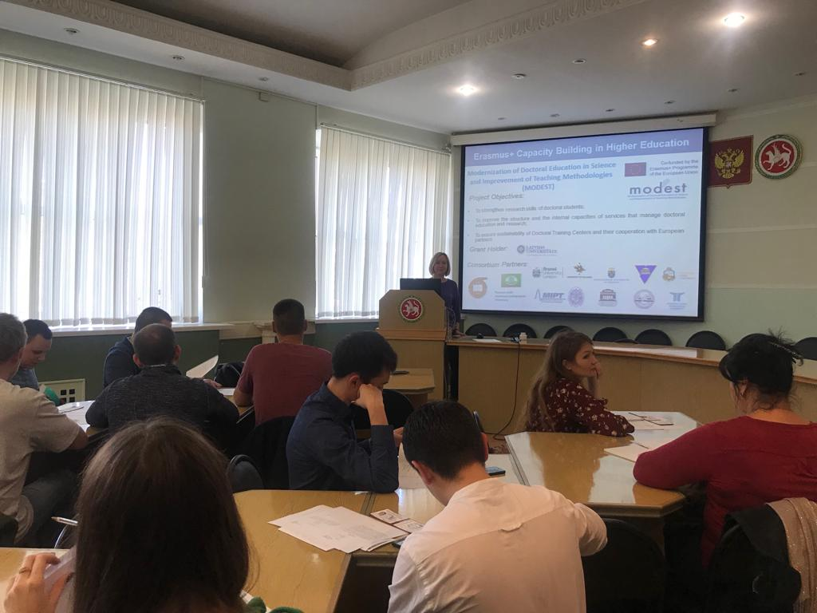
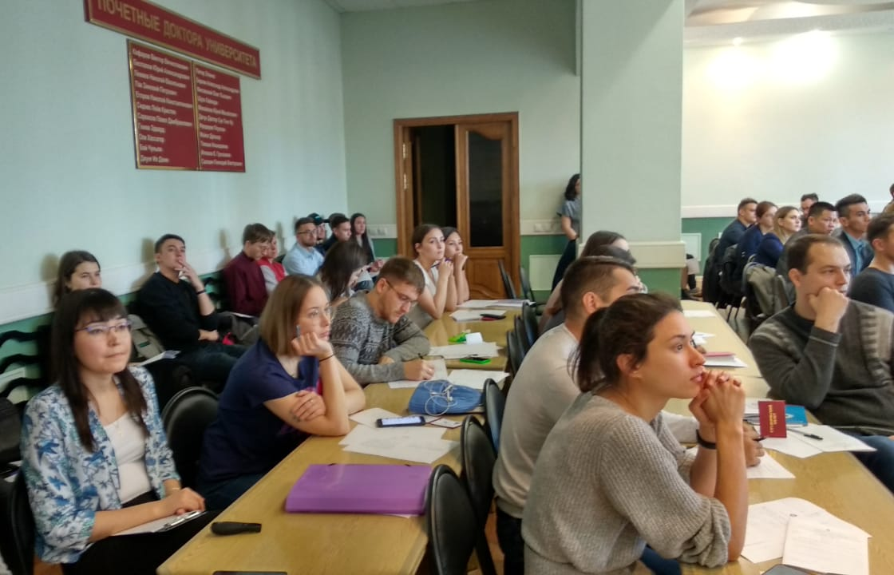
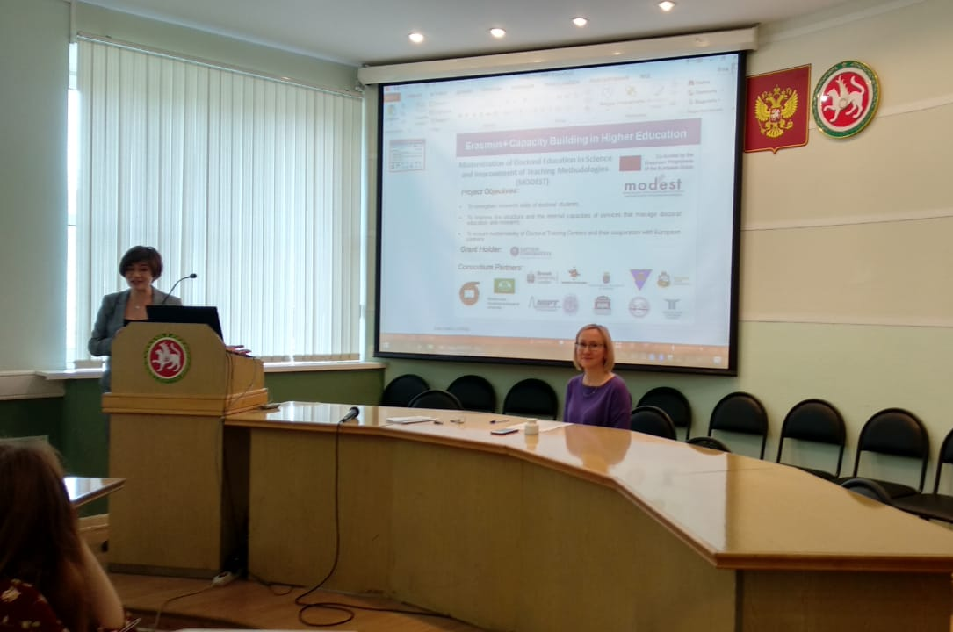
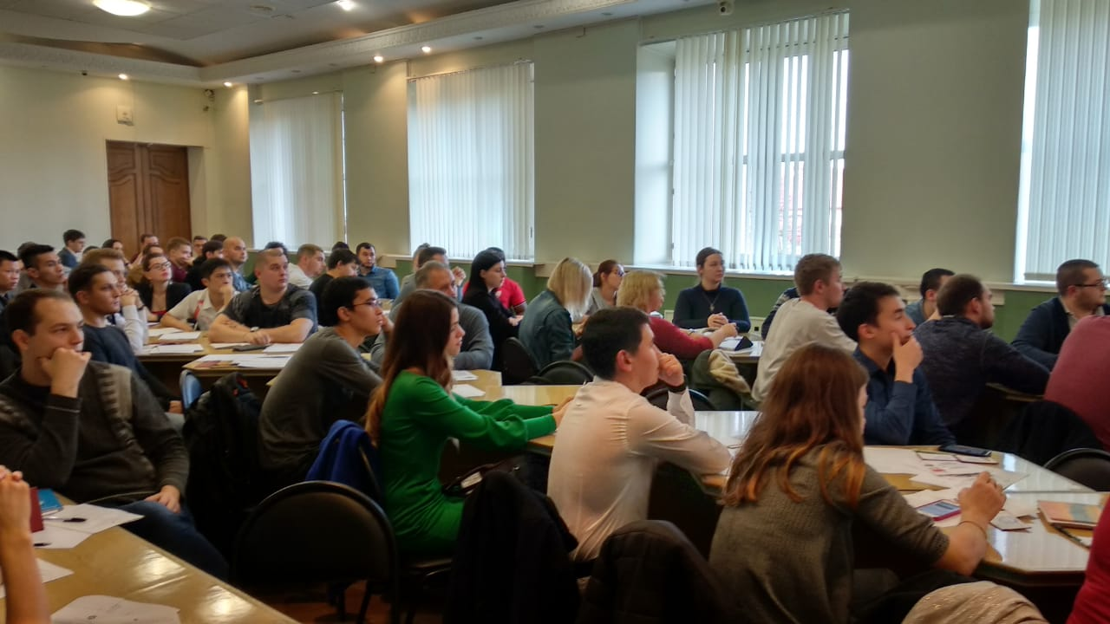

Annex 3.
Information about MODEST consortium activities in the annual report to the Russian Ministry of Higher Education and Science dedicated to P10 activities as a national research university.
