Institution | Kazan National Research Technological University | Reporting period | 16.02.2021 – 31.06.2021

Key for “Type” of activity: A. Distribution of information
B. Project presentations
C. Articles and postings (websites, blogs, newspapers, journals, books etc.).
Note: you do not need to fill in columns marked with * for type C.
D. Other activities

No | Country | Type | Description of the activity  (‘Medium’ used, if entry is for an activity of type C) | Target groups | No. of  institutions* | No. of  Persons* | Date | Documentation | Comments  (effects, observations, problems etc.)
 | RU | A,B | Presentation of the MODEST Project and distribution information about the MODEST Consortium among the KNRTU PhD students, faculty, and staff at the Seminar “Human Resources – 50 projects” hosted at KNRTU | KNRTU administration, Academic Council, PhD students, faculty, and staff | 1 | >60 | 27.02.2021 |  | Please see Annex 1
 | RU | C | Information about the presentation of the MODEST Project among the KNRTU PhD students, faculty, and staff at the Seminar “Human Resources – 50 projects” published at KNRTU website | KNRTU Rectorate, administration, Academic Council, PhD students, faculty, and staff |  |  | 11.03.2021 | https://www.kstu.ru/knrtu/event.jsp?id=119773
 | EN | B | Kazan National Research Technological University hosted an online seminar entitled "Research Methodology: from Setting a Hypothesis to Publication". The seminar presented a part of the MODEST project activities: development of courses for PhD students. |  | >10 | >100 | 18.03.2021 |  | Please see Annex 2
 | EN | C | The news about the webinar "Research Methodology: from Setting a Hypothesis to Publication" published in the MODEST Consortium website | PhD students, faculty, and staff from the MODEST Consortium Partner institutions |  |  | 18.03.2021 | https://www.emodest.eu/index.php/meetings/26-webinar-on-research-methodology-from-setting-a-hypothesis-to-a-publication
 | EN | C | The news about the webinar "Research Methodology: from Setting a Hypothesis to Publication" published in the KNRTU website | KNRTU Rectorate, administration, Academic Council, PhD students, faculty, and staff |  |  | 18.03.2021 | https://www.kstu.ru/knrtu/event.jsp?id=119773
 | EN | A | KNRTU participation in Erasmus + MODEST Webinar on Commercialization of Research | KNRTU, administration, professors, and PhD students | >10 | >100 | 08.04.2021 |  | Please see Annex 3
 | EN | C | Information about KNRTU participation in Erasmus + MODEST Webinar on Commercialization of Research published in KNRTU website | KNRTU Rectorate, administration, Academic Council, PhD students, faculty, and staff |  |  | 09.04.2021 | https://www.kstu.ru/knrtu/event.jsp?id=120600
 | RU | A | Opening ceremony of the Doctoral Training Center was performed at KNRTU with invited partner institutions, PhD students, and mass media | KNRTU, administration, professors, PhD students, and partner institutions | 7 | >30 | 01.06.2021 |  | Please see Annex 4
 | RU | C | Information about opening ceremony of the Doctoral Training Center published in KNRTU website | KNRTU Rectorate, administration, Academic Council, PhD students, faculty, and staff |  |  | 02.06.2021 | http://www.kstu.ru/event.jsp?id_a=24247&id=122033
 | EN | C | The post “KNRTU Launches a Doctoral Training Center for Graduate Students and Young Scientists under Erasmus+ Project” published in KNRTU website | KNRTU Rectorate, administration, Academic Council, PhD students, faculty, and staff |  |  | 02.06.2021 | https://www.kstu.ru/knrtu/event.jsp?id=122044
 | RU | A | Meeting of the MODEST Consortium members with the KNRTU top management and discussion on ongoing project activities. Signing the collaboration agreement with National Polytechnic University of Armenia | KNRTU Rectorate and administration | 7 | 15 | 02.06.2021 |  | Please see Annex 5
- ] | RU | A,B | Meeting of the MODEST Consortium members with KNRTU administration, PhD students, and administration of Russian universities | KNRTU, administration, professors, PhD students, and partner institutions | 7 | >30 | 02.06.2021 |  | Please see Annex 6
 | RU | C | Information about meeting of the MODEST Consortium members with KNRTU administration, PhD students, and administration of Russian universities published in KNRTU website | KNRTU Rectorate, administration, Academic Council, PhD students, faculty, and staff |  |  | 03.06.2021 | http://www.kstu.ru/event.jsp?id_a=24247&id=122064
 | EN | C | The post “Meeting of Erasmus+ MODEST Consortium Members with KNRTU Administration, Scientists and Postgraduate Students” published in KNRTU website | KNRTU Rectorate, administration, Academic Council, PhD students, faculty, and staff |  |  | 03.06.2021 | https://www.kstu.ru/knrtu/event.jsp?id=122068
 | RU | C | Information about meeting of the MODEST Consortium members with the KNRTU top management published in KNRTU website | KNRTU Rectorate, administration, Academic Council, PhD students, faculty, and staff |  |  | 03.06.2021 | http://www.kstu.ru/event.jsp?id_a=24247&id=122067
 | EN | C | The post “KNRTU Signs an Agreement with the National Polytechnic University of Armenia” within the framework of the MODESt Consortium published in KNRTU website | KNRTU Rectorate, administration, Academic Council, PhD students, faculty, and staff |  |  | 03.06.2021 | https://www.kstu.ru/knrtu/event.jsp?id=122069
 | RU | C | Publication about opening the KNRTU Doctoral Training Center in the regional newspaper “Business Online” | Regional audience of the Republic of Tatarstan in Russia |  |  | 03.06.2021 | https://www.business-gazeta.ru/news/511553
 | RU | C | Publication about opening the KNRTU Doctoral Training Center in the regional branch of the Russian federal newspaper “Komsomolskaya Pravda”. | Regional audience of the Republic of Tatarstan in Russia |  |  | 03.06.2021 | https://www.kazan.kp.ru/online/news/4314368/ | Please see Annex 7
 | RU | C | Distribution of information about the MODEST project at the regional television | Regional audience of the Republic of Tatarstan in Russia |  |  | 04.06.2021 |  | Please see Annex 8

Annex 1.
Presentation of the MODEST Project and distribution information about the MODEST Consortium among the KNRTU PhD students, faculty, and staff at the Seminar “Human Resources – 50 projects” hosted at KNRTU.

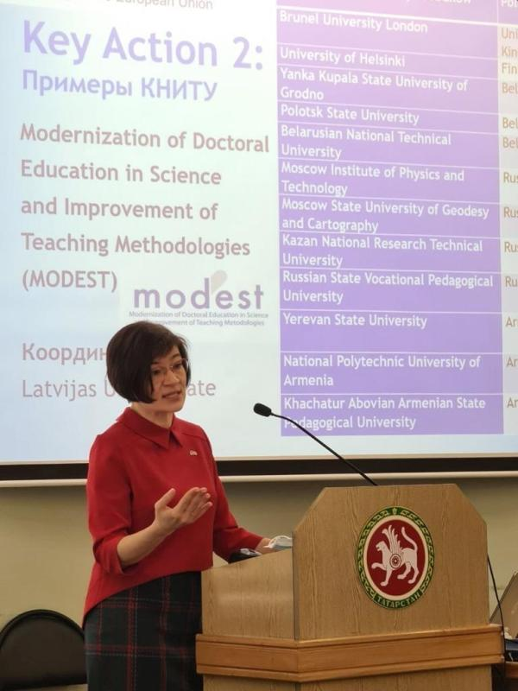

Annex 2.
Research Methodology Seminar

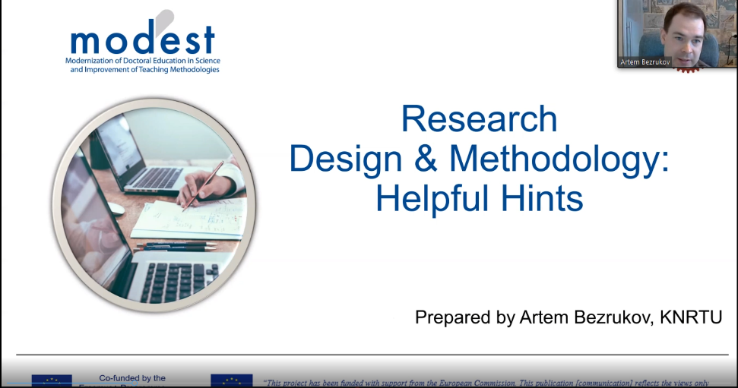

Annex 3.
KNRTU Took Part in Erasmus + MODEST Webinar on Commercialization of Research.

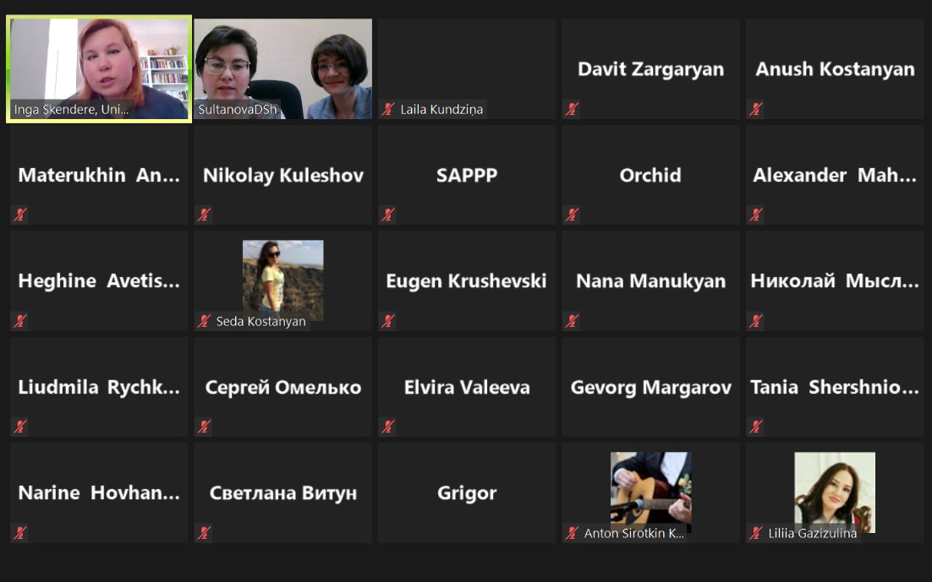. 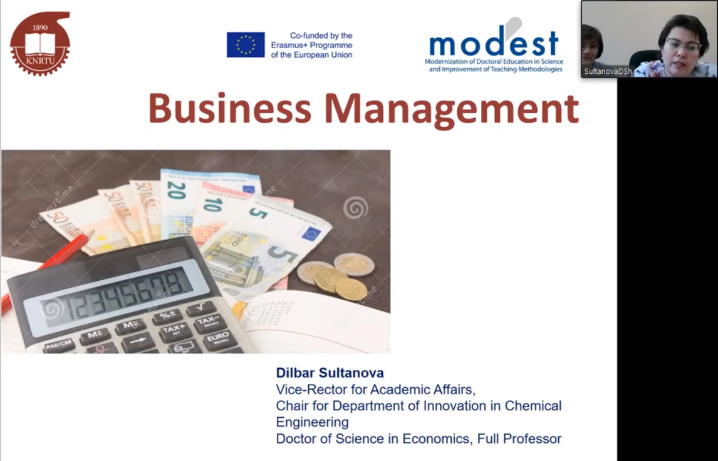

Annex 4.
Opening Doctoral Training Center at KNRTU

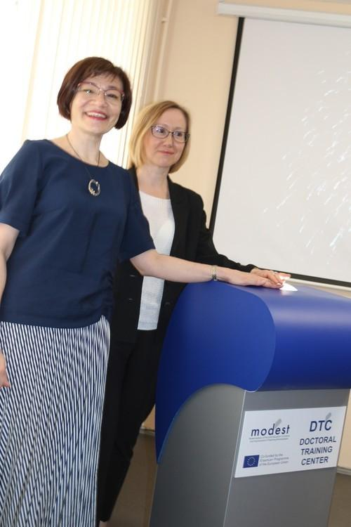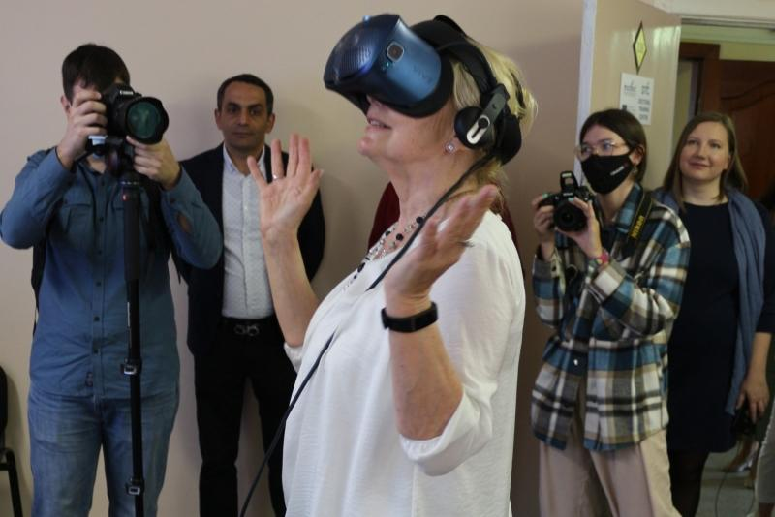

Annex 5.
Meeting of MODEST consortium members with KNRTU Acting Rector Dr. Yury Kazakov. Signing the collaboration agreement with National Polytechnic University of Armenia.
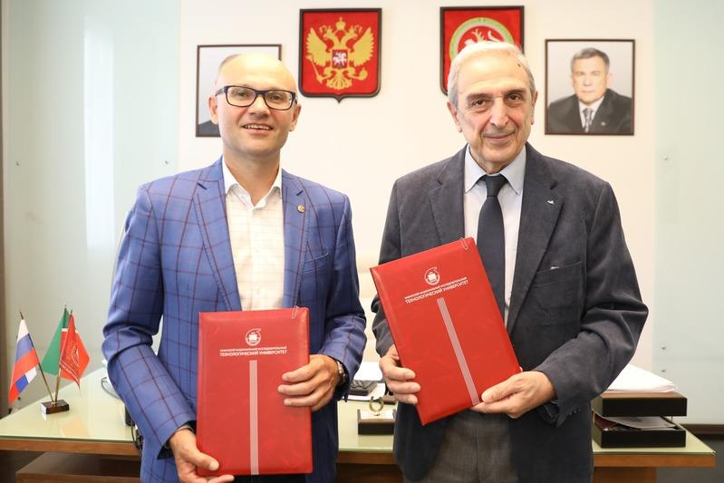
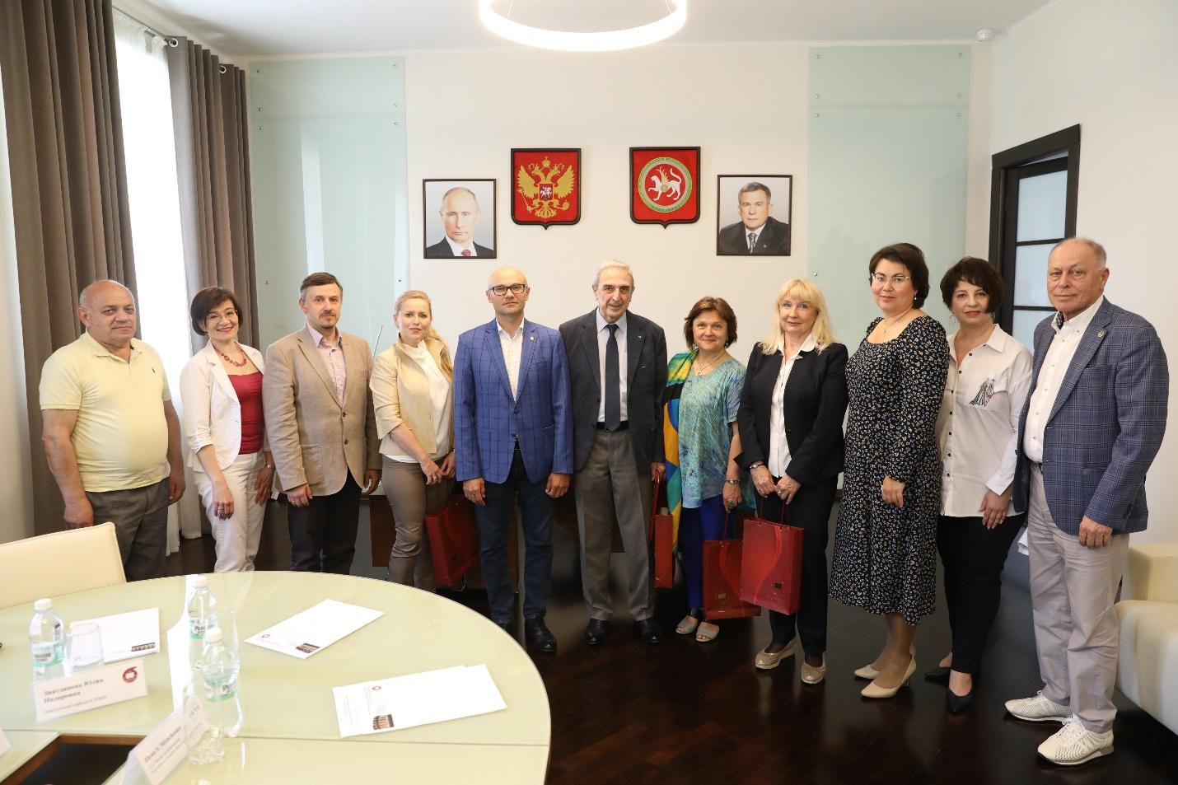

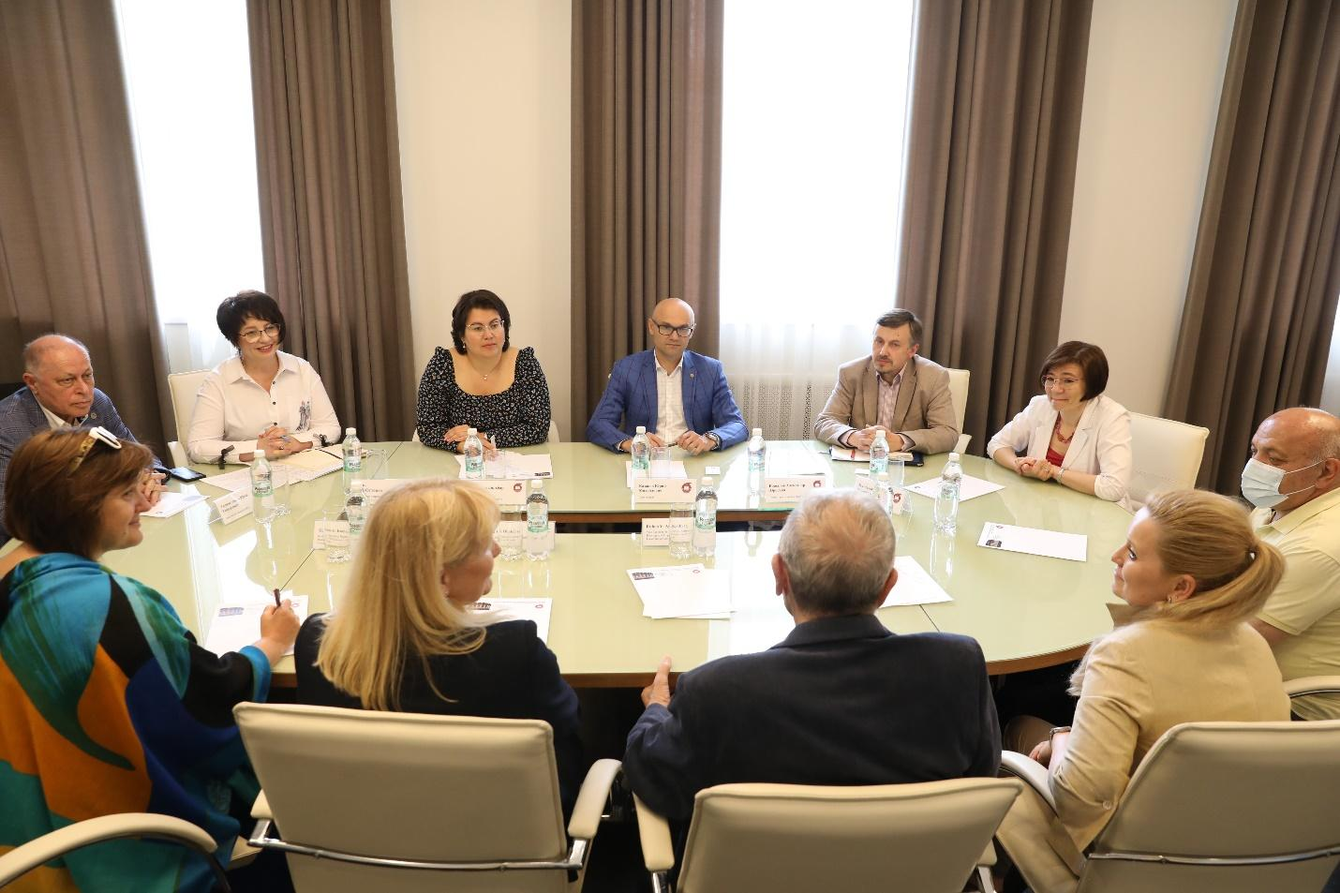
Annex 6.
Meeting of the MODEST Consortium members with KNRTU administration, PhD students, and administration of Russian universities

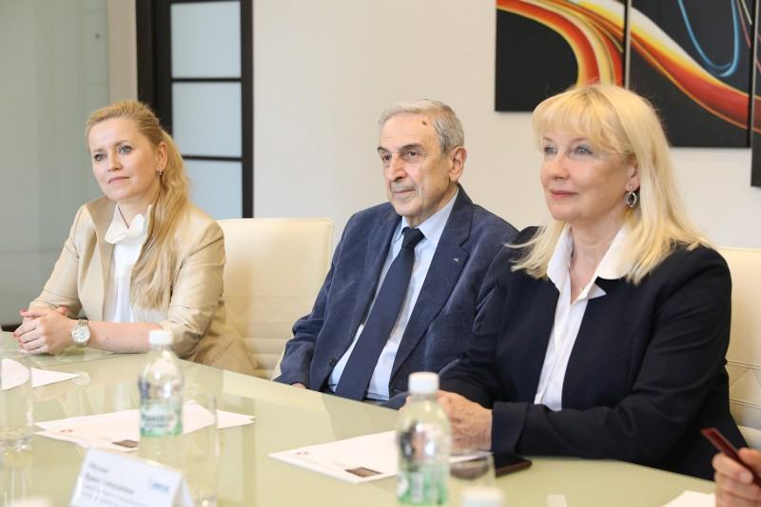

Annex 7.
Publication about the Doctoral Training Center opening in the Russian federal newspaper “Komsomolskaya Pravda”.

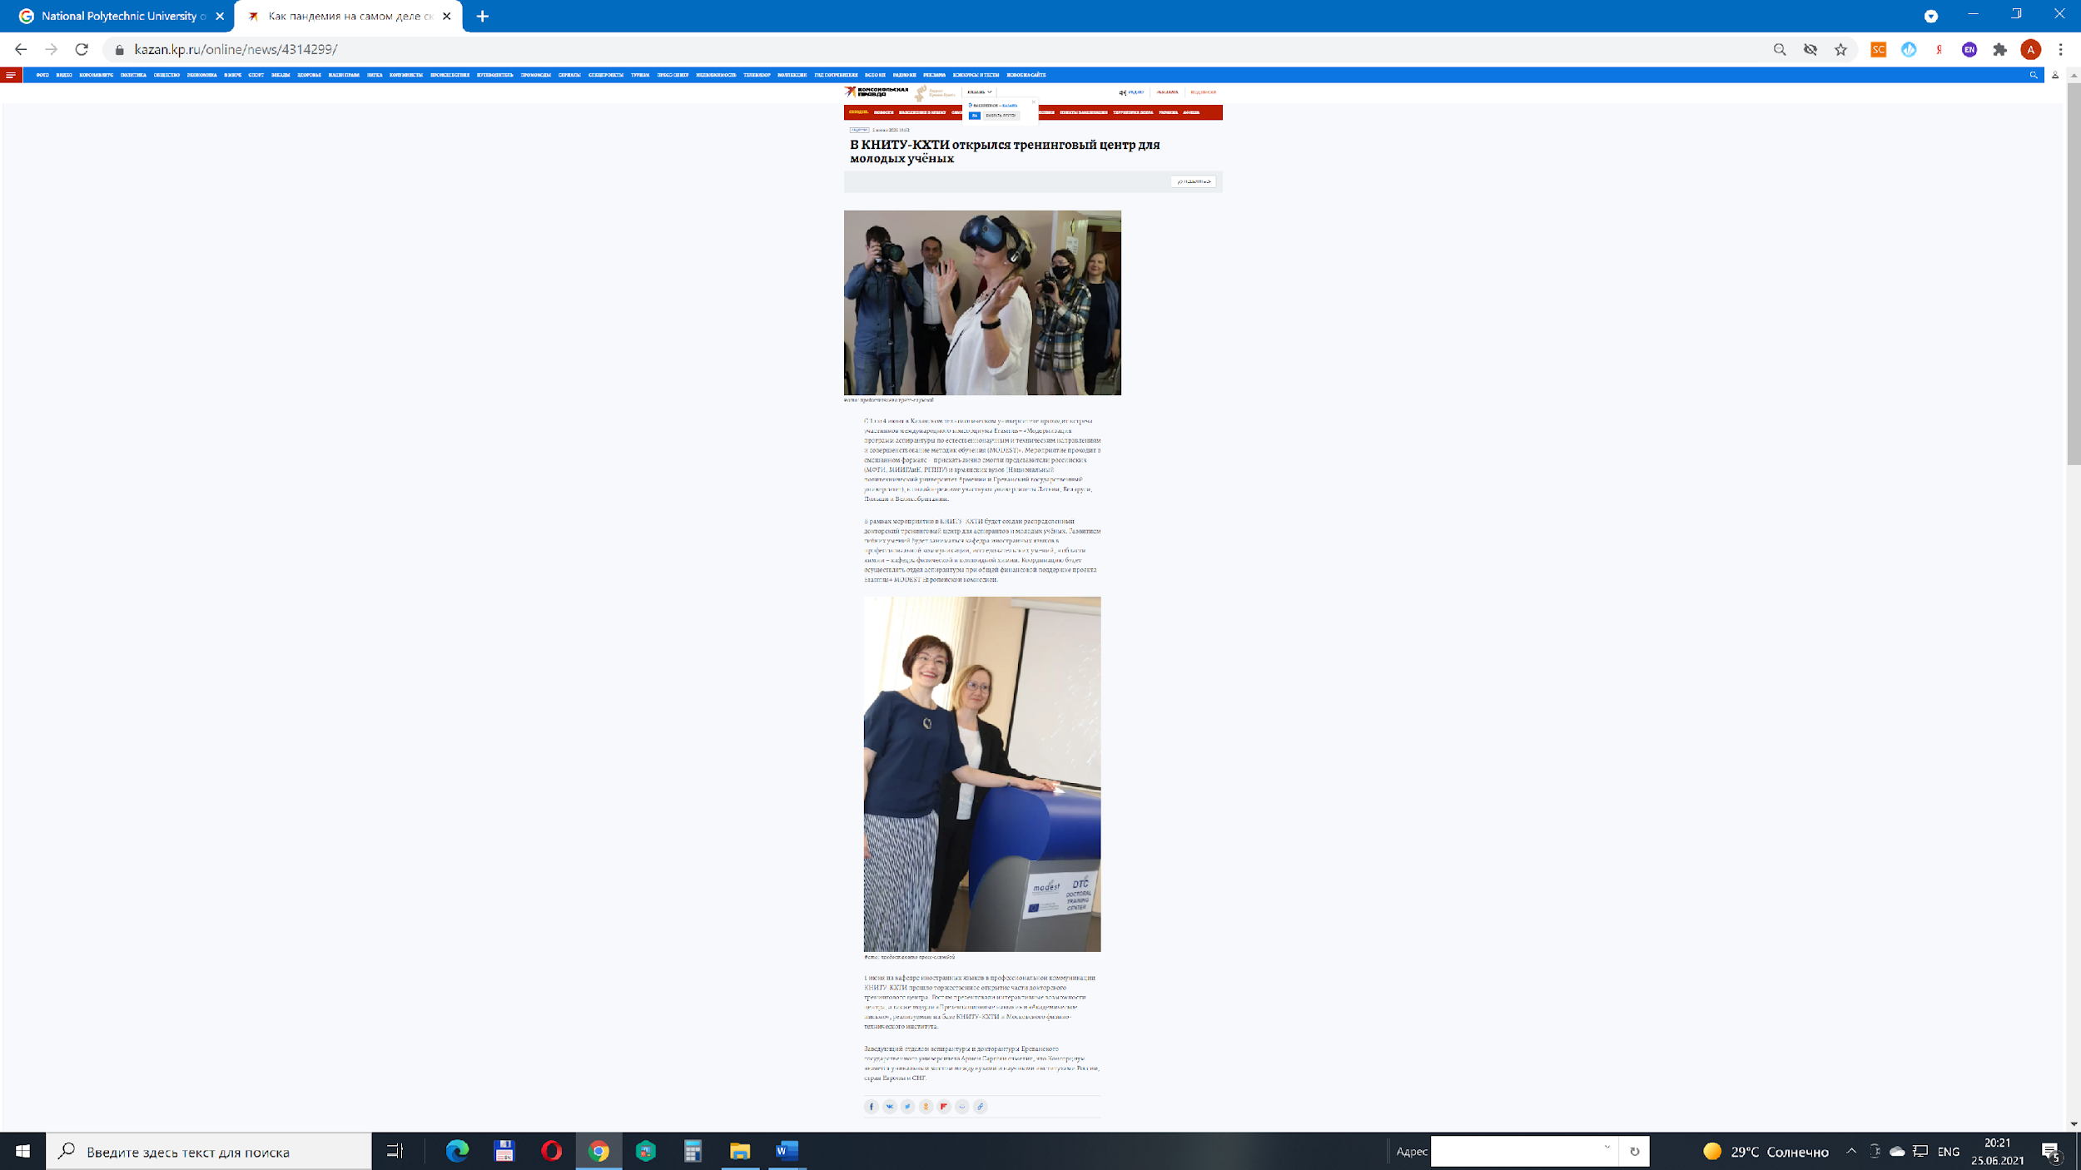
Annex 8.
Distribution of information about the MODEST project at the regional television

